Ames test
The Ames test (Salmonella typhimurium reverse mutation assay) is a bacterial short-term test for identification of carcinogens using mutagenicity in bacteria as an endpoint.
In 1974, Bruce Ames developed a simple test for evaluating the potential of chemicals to cause cancer. The Ames test is based on the principle that both cancer and mutations result from damage to DNA, and the results of experiments have demonstrated that 90% of known carcinogens are also mutagens.
Bruce Ames and his associates developed sensitive techniques that allow the mutagenicity of large no. of chemicals to be tested quickly, at relatively low cost. Ames proposed that mutagenesis in bacteria could serve as an indicator of carcinogenesis in humans.
The Ames test uses different auxotrophic strains of the bacterium Salmonella typhimurium that have defects in the lipopolysaccharide coat, which normally protects the bacteria from chemicals in the environment. Furthermore, the DNA-repair system in these strains has been inactivated, enhancing their susceptibility to mutagens.
The most recent version of the test (called Ames II) uses several auxotrophic strains that detect different types of base-pair substitutions. Other strains detect different types of frameshift mutations. Each strain carries a his– mutation, which renders it unable to synthesize the amino acid histidine, and the bacteria are plated onto medium that lacks histidine. Only bacteria that have undergone a reverse mutation of the histidine gene (his– → his+) are able to synthesize histidine and grow on the medium.
Different dilutions of a chemical to be tested are added to plates inoculated with the bacteria, and the number of mutant bacterial colonies that appear on each plate is compared with the number that appear on control plates with no chemical (i.e., that arose through spontaneous mutation).
Any chemical that significantly increases the number of colonies appearing on a treated plate is mutagenic and is probably also carcinogenic.
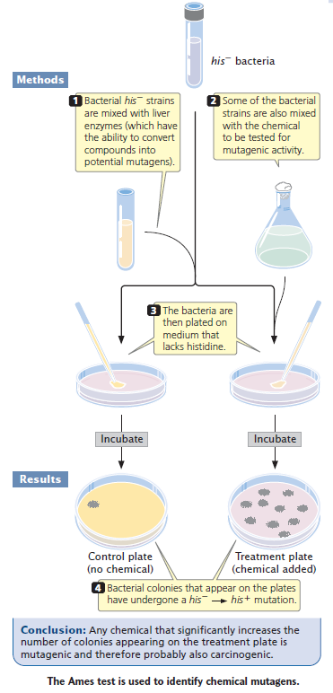
Because some chemicals are mutagenic only to replicating DNA, addition of small amount of histidine to the medium is sometimes required: an amount enough to allow a few cell divisions but not the formation of visible colonies.
Some compounds are not active carcinogens but can be converted into cancer-causing compounds in eukaryotic cells. To make the Ames test sensitive for such potential carcinogens, a compound to be tested is first incubated in mammalian liver extract that contains metabolic enzymes. Rat liver enzymes act on a substance the same way human livers do. Thus, adding rat liver extract to the assay system of Ames test expands the utility of the system considerably.

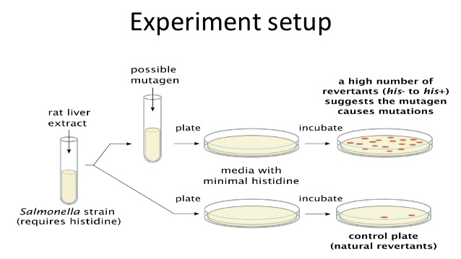

Mutator genes
Any gene that alters the rate of spontaneous mutation in other genes of that organism are called mutator genes, they include genes that take part in DNA synthesis, such as the genes encoding DNA polymerase. Other mutator genes are involved in DNA repair. They have been analyzed in detail in bacteria, although less is known for humans.
Mutator genes (genes that elevate the genomic mutation rate) are likely to induce deleterious mutations and thus suffer an indirect selective disadvantage; at the same time, bacteria carrying them can increase in frequency only by generating beneficial mutations at other loci.
Gene inactivation has commonly been used to search for mutator genes and mutational pathways. In bacteria, over 15 spontaneous mutator genes and their corresponding mutational pathways have been identified by means of mutagen‐mediated point mutation inactivation or transposon‐mediated insertion inactivation. For example, genes involved in mismatch repair (dam, mutS, mutL, mutH and uvrD), repair and avoidance of oxidative damage (mutY, mutM and mutT), and DNA proofreading (mutD) result in a mutator phenotype when inactivated.
Other genes encode nucleoside diphosphate kinase (ndk), the positive regulator of oxidative damage gene (oxyR), superoxide dismutase (sodA, sodB) and even tRNAs (mutA, mutC).
Some studies have also shown that certain genes cause elevated levels of mutation when overexpressed, such as dinB that encodes the error‐prone DNA polymerase IV

References
- Genetics- a conceptual approach by Benjamin A Pierce
- Genetics by D. Peter Snustad and Michael J. Simmons
- https://doi.org/10.1111/j.1365-2958.2004.04125.x

